|  |  |  |  |  |
| --- | --- | --- | --- | --- |
| **Index** | | | | |
| **Sr No.** |  | **Description** | | **Page No** |
| **1** |  | **DDU Profile** | |  |
| **2** |  | **Company Profile** | |  |
| **3** |  | **Project Profile** | |  |
| **4** |  | **Tools and Technologies** | |  |
| **5** |  | **Planning** | | |
|  | **5.1** | Project Definition | |  |
|  | **5.2** | Preliminary Investigation | |  |
| **6** |  | **System Analysis** | |  |
|  | **6.1** | Feasibility Study | |  |
|  | **6.2** | System Requirement Specification | |  |
| **7** |  | **System Design** | |  |
|  | **7.1** | Architectural diagrams | | |
|  |  | **7.1.1** | Use case Diagram |  |
|  |  | **7.1.2** | Activity Diagrams |  |
|  |  | **7.1.3** | Class Diagram (1. Classes/interfaces, 2. Class diagram) |  |
|  |  | **7.1.4** | Sequence Diagram |  |
|  | **7.2** | **ER Diagram** | |  |
|  | **7.3** | **Data Dictionary** | |  |
| **8** |  | **Implementation & Testing** | |  |
|  | **8.1** | Screen Snapshots | |  |
|  | **8.2** | Reports (giving important outputs of the project) | |  |
|  | **8.3** | Testing | |  |
|  |  | **8.4.1** | Test Strategy |  |
|  |  | **8.4.2** | Test Cases and Results |  |
| **9** |  | **Future Enhancement** | |  |
| **10** |  | **Bibliography** | |  |

1. **DDU Profile**

Dharmsinh Desai University (DDU), located at Nadiad is one of the leading institutions of learning in Gujarat. Since inception in 1968 as an institute for higher education in technology and engineering by the then Member of Parliament, Shri Dharmsinh Dadubhai Desai, it is committed to grooming students for leadership roles in the society.

Having modesty started with Diploma and Degree courses in Chemical Engineering. It has by now grown as top most Institute of Gujarat offering Graduate and Post Graduate level courses in various disciplines, and ultimately has become a State University in the year 2005. The institute gained an autonomous status in 1999 with approval from UGC and Gujarat Government and become a Deemed University accredited by N.B.A. in the year 2000.This University offers Graduate and Post Graduate level courses in various disciplines and Master of Computer Applications (MCA) is being run under Faculty of Management and Information Science since 1987. DDU’s Mission is to undertake programs and projects for development of human resources, both through formal and non- formal delivery systems, in areas of professional pursuits in all walks of human endeavors, with accent on relevance, value addition, societal needs and futuristic pilot projects.

In November 2013, the organization in UK, the 'Oxford Summit of Leaders', chose Dharmsinh Desai University as the best regional university. This is the first time the Oxford Group has given this award to a university outside Europe. The University has been accredited by UGC NAAC.

D.D. University believes not only in providing quality education, but also provides an overall development of its students in the form of being disciplined, sociality accountable to the society and responsible citizen of our county.

The University runs various courses in Technology, Pharmacy, Management and Information Sciences, Dental Sciences, Medical Sciences.

1. **Company Profile**



**Company Name**: Proses Web Technologies Pvt. Ltd.

Company Address: 311,312 Park Paradise, Ring Rd, near Billabong High school, Vadsar, Kalali, Vadodara, Gujarat 390012

# Company Overview:

PROSES is a place where innovative business ideas are converted into

Technical reality. Established in 2005 with a purpose to bring positive difference in the business modules with the involvement of advanced technology. Our idea is to connect the dots of the businesses with web technology to ensure flawless and quick completion of the distinct business procedures. This helps businesses to grow at rapid pace in brief time.

# Mission:

We believe not only in offering solution but ensuring positive connection with our clients. Thus, we offer endless solution to our customers and seek for further assistance needed by our customers. This makes us trusted customer-centric solution provider. Therefore, our mission varies with the requirements of the

Clients. After-all, we just not work for them but we live their projects.

# Services:

Web Development Mobile Development IOT / Beacons UI/UX

Sound Support

At PROSES, we work at the core concept of web and mobile development

Where we look at every single aspect and requirement of the clients; so that both can be interweaved into an application to ensure high-end web & mobile

1. **Project Profile**

|  |  |
| --- | --- |
| **Company name** | Proses Web Technologies Pvt. Ltd |
| **Project title** | Employee Management System |
| **Project Definition** | An employee management system or EMS is a tool that helps improve employee satisfaction and productivity to help a company achieve their overall goals. |
| **Project description** | The Employee Management System (EMS) is a software application designed to Management of employee data within an organization. This system provides functionalities for managing employee information, such as personal details,  leave requests  **admin:** Admin (Full Rights)  **manager:** employee(Rights) |
| **Aim of Project** | Employee Management System Project is designed to keep track of employee information in any company. It stores data such as their employees' personal information leave details |
| **Tools/Technologies** | HTML, JavaScript, React, Bootstrap, MySQL, Node |
| **Duration** | 4 Month |
| **Team Size** | 1 |
| **Type** | Web Application |
| **Internal guide** | **Prof. Minal Shah** |
| **External guide** | **Mr. Parthiv Shah** |

1. **Tools and Technologies**

|  |  |
| --- | --- |
| **Front End** | HTML, Bootstrap, JavaScript, React js |
| **Back End** | Node js |
| **Database** | MySQL Server |
| **Tools/ Technology** | Visual Studio Code, |
| **Type of application** | Web Application |

1. **Planning**
   1. **Project Definition**

An employee management system is a system that helps to improve employee management and productivity to help a company achieve their overall goals. These system help monitor, assess and control employees' working hours. It include Manager efficiently manages each employee's and distribute salaries on time

With the help of employee management system the Manager department can implement processes and help companies achieve their business objectives. By helping managers keep track of admin activities, the system can help improve employee engagement and increase productivity. These system also help an organization for Leave management.

* 1. **Preliminary Investigation**

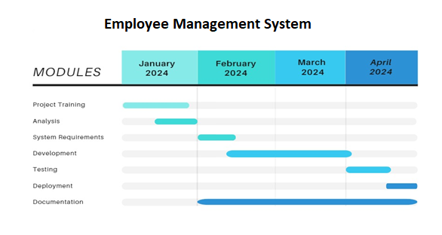

1. **System Analysis**
   1. **Feasibility Study**

* **Technical Feasibility:**
* **System Requirements**:

The EMS will require technical infrastructure including servers, databases, and network connectivity. Assessing the availability of these resources within the organization or the ability to procure them externally is essential.

* **Technology Stack:**

Determine the feasibility of using appropriate technologies for development, considering factors such as compatibility, scalability, and integration capabilities with existing systems.

* **Security**:

Evaluate the feasibility of implementing robust security measures to safeguard employee data, including encryption, access controls, and regular security audits.

* **Economic Feasibility:**
* **Cost Analysis**:

Estimate the development, deployment, and maintenance costs associated with implementing the EMS. Consider factors such as software licensing, hardware infrastructure, development resources, and ongoing support.

* **Return on Investment (ROI**):

Assess the potential ROI by quantifying the benefits of the EMS, such as improved employee productivity, streamlined HR processes, reduced administrative overhead, and compliance with labour laws. Compare these benefits against the projected costs to determine economic feasibility.

* **Operational Feasibility:**
* **User Requirements:**

Gather user requirements from HR professionals, managers, employees, finance department, training teams, and recruiters to ensure that the EMS meets their operational needs.

* **Change Management:**

Assess the organization's readiness for adopting the EMS, including potential resistance to change and strategies for managing organizational change effectively. Consider factors such as user training, communication plans, and stakeholder engagement.

* **Legal and Regulatory Feasibility:**
* **Data Privacy and Compliance:**

Ensure that the EMS complies with data protection regulations (e.g., GDPR, HIPAA) and labour laws regarding employee records, working hours, payroll processing, and confidentiality. Assess the feasibility of implementing necessary controls and procedures to achieve compliance.

* **Schedule Feasibility:**
* **Project Timeline**:

Develop a detailed project plan with milestones and deadlines for different phases of development, testing, deployment, user training, and support. Assess the feasibility of meeting these timelines based on resource availability, complexity of the project, and potential risks.

|  |  |  |  |  |
| --- | --- | --- | --- | --- |
| **Sr No.** |  |  | **Topic** | **Page No** |
| **1** |  |  | **Introduction** |  |
|  | **1.1** |  | Purpose |  |
|  | **1.2** |  | Definition |  |
|  | **1.3** |  | Scope |  |
|  | **1.4** |  | Intended Audience and Users |  |
| **2** |  |  | **Overview** |  |
|  | **2.1** |  | Environmental Characteristics |  |
|  |  | **2.1.1** | Hardware / Software |  |
|  |  | **2.1.2** | Peripheral |  |
|  |  | **2.1.3** | People |  |
|  | **2.2** |  | Overview |  |
|  | **2.3** |  | Acronyms & Abbreviation |  |
|  | **2.4** |  | References |  |
| **3** |  |  | **Specification Requirements/ Functional Requirements** |  |
|  | **3.1** |  | User Authentication |  |
|  | **3.2** |  | User Interface |  |
|  | **3.3** |  | Various roles |  |
|  | **3.4** |  | User Class |  |
|  |  | **3.4.1** | Attributes |  |
|  |  | **3.4.2** | Methods |  |
|  |  | **3.4.3** | Access Control |  |
|  |  | **3.4.4** | Password Management |  |
|  |  | **3.4.5** | Relationships |  |
| **4** |  |  | **Non-Functional Requirements** |  |
|  | **4.1** |  | Accessibility, Reliability and Availability, Performance, Security |  |
|  | **4.2** |  | Interfaces |  |
|  |  | **4.2.1** | External Interfaces |  |
|  |  | **4.2.2** | User Interfaces |  |
|  |  | **4.2.3** | Software Interfaces |  |
|  |  | **4.2.4** | Communication Interfaces |  |
|  | **4.3** |  | Portability, Licensing, Legal copyright or Other Notices |  |
|  | **4.4** |  | Applicable standards |  |
| **5** |  |  | **Behavioral Description** | |
|  | **5.1** |  | System States |  |
|  | **5.2** |  | Events and Actions |  |

* 1. **System Requirement Specification**

1. **Introduction**

The Employee Management System (EMS) is a software application designed to streamline the management of employee data within an organization. This system provides functionalities for managing employee information, such as personal details, attendance, leave requests, performance evaluations, and payroll processing.

* 1. **Purpose**

Employees are the backbone of any company; their management pays a major role in deciding the success of the organization. Understands this fact and therefore designed a unique and 100% functional employee management system. This system uses employee management software that helps in assembling, organizing and managing the information of the employees as required by you. Every organization has different employee management issues to be addressed, so we design customized employee information management system that could fit into your company's requirement frame.

Employee information management helps in deciding the future management needs and any changes that has to be made for greater productivity. Employee management software can carry out many functions like employee data analysis, employee monitoring, centralized employee database, etc.

* 1. **Definition**

The Employee management system describes the management of employee and all the authorization are in the hands of admin and some of part through the manager.

It ensures that Manager efficiently manages each employee's payroll and disburses salaries on time. An EMS securely stores and manages the personal and work-related details of employees. This makes it easier for the managers to store and access relevant data when needed.

With the right EMS tool, the Manager department can implement processes and help companies achieve their business objectives. By helping managers keep track of admin activities, the tool can help improve employee engagement and increase productivity. It can even help Manager and organizational leaders track performance reviews of employees.

* 1. **Scope**

The Employee management system is used by human resource managers as well for analyses of any organization. It includes salary of every employee, admin can have full rights of add, update, delete employee, and manger. Admin can also modify data within the system. Manager can also rights of add, update, delete employee, manager can also modify data as well as leave approvals and decline of employees are goes under the managers.

In fixed scope, when you send us the enquiry, we determine the scope of timeline estimate upfront. Once you send us the enquiry, we analyze the same and reply to you with our understanding of your requirements along with the queries and suggestions. After we receive your clarifications, we finalize the scope of work, determine which technology will be used for this project and give you the timeline estimate. After we receive your approval on the pricing and timeline, we start with the project development which begins with requirement analysis by the technical team. Once the project is complete in the local system, we deploy the project. Subsequently our team does the quality testing of your project and after their approval we ask you to test the functionalities and after approval, we close the project.

* 1. **Intended Audience and Users**
* **Human Resources (HR) Professionals:**

HR managers and specialists are the primary users of an employee management system. They have to work on their human resource and make them feel better as well as via less efforts. All this requirements can filled up by the Employee management system.

* **Decision-makers:**

Decision-makers, including executives and organizational leaders they have to analyse on organizations man power as well as they can take decision regarding new joining as well as their management.

* **Managers and Supervisors:**

Team leaders, department heads, and supervisors use the system to monitor and manage the performance of their team members, assign tasks, conduct performance appraisals, and ensure compliance with company policies.

* **Employees:**

Individual employees use the system to access their personal information, submit leave requests, view pay stubs, update personal details, and participate in performance evaluations. A user-friendly interface for employees is essential to encourage engagement.

* **Data Analysts:**

Another important audience is data analyst. Their main work is to analyse employee data while distributing allowances, their expenses on their human property.

* **Recruiters:**

Recruiters use the system during the hiring process to manage job postings, applications, candidate evaluations, and communication with potential hires.

1. **Overview** 
   1. **Environmental Characteristics** 
      1. **Hardware/Software**

**Software**

Name of component Specification

Operating System Windows7, Windows10, Windows11

Language React, HTML, JavaScript, Bootstrap,

CSS.

Database MySQL Server

Browser Chrome, Internet Explorer, Microsoft Edge

Web Server Apache

Software Development Kit Node

Scripting Language Enable JavaScript

## **Hardware**

Name of component Specification

Processor Intel(R) Core (TM) i5-5200U

Monitor 15” Color Monitor

RAM 8 GB

Hard disk 20GB

Keyboard 122 Key

* + 1. **Peripheral**

No specific peripheral hardware is required for accessing the C Dashboard of Employee management system. Employee, manager and admin can interact with the platform using standard input devices such as keyboards and mice, along with displays (monitors/screens) for visualizing the data.

* + 1. **People**
* **Development Team:**

**Software Engineers:** Responsible for developing front-end and back-end components, implementing features, and ensuring system functionality.

**UI/UX Designers:** Design user interfaces, wire-frames, and prototypes

For optimal user experience.

* **End-users:**

**Employee:** This are the vital role who use this system. To show their profile, attendance, salary.

**Admin:** The handler or in other words primary user which handles the data, authorizations, protocols etc.

**Managers:** The middleware or which are being monitors of the Employee Management System.

**Human Resources Managers:** Use demographic and income data to understand workforce characteristics and plan recruitment strategies.

* 1. **Overview**

The Employee Management System is used to handle employee data and being easy handler to manage human force and their profiles.

* 1. **Acronyms & Abbreviation**

Employee Dashboard (ED): The web-based platform designed to showcase Employee data.

EMS: Employee Management System

HRMS: Human Resource Management System

HRIS: Human Resources Information System

EHR: Employee Health Record

EIS: Employee Information System

TMS: Talent Management System

ATS: Applicant Tracking System

PMS: Performance Management System

T&A: Time and Attendance

DMS: Document Management System

* 1. **References**

Human resource activities

Node libraries

1. **Specification Requirements/ Functional Requirements**

* A log in facility for enabling only authorized access to the system.
* System administrator will be able to add, modify, enable, disable or delete any feature like, employee information, and login information.
* System administrator will be able to create login credentials for new employees.
* Employees will be able to view their information.
* An employee cannot view other employee details.
  1. **User Authentication**

Requirement 3.1.1: Users must authenticate themselves before accessing the Employee management dashboard.

Requirement 3.1.2: Authentication mechanisms such as Email and password.

* 1. **User Interface**

Requirement 3.2.1: The dashboard shall display various navigates to Display employee data.

Requirement 3.2.2 Admin can add and update employee and employee can get data.

* 1. **Various roles**

Requirement 3.3.1: There is 3 roles and all of them can get their Screens. There are Employee, manager, admin.

* 1. **User Class**
     1. **Attributes**

Employee ID: A unique identifier for each employee.

Name: The full name of the employee.

Username and Password: For user authentication and access control.

Contact Information: Such as email.

Position: The position or role of the employee within the organization. Department: The department to which the employee belongs.

* + 1. **Methods**

Getters and Setters: For accessing and updating the attributes of the user. Authentication: Verify the username and password for login purposes.

Update Profile: Allow the user to update their contact information. View Personal Information: Display the employee's details.

* + 1. **Access Control**

Authorization Check: Ensure that the user has the necessary permissions for certain actions or access.

* + 1. **Password Management**

Password: passwords, ensure they are secure.

* + 1. **Relationships**

Manage Relationships: If the system involves hierarchical relationships or reporting structures, the User class may need methods to manage these relationships

1. **Non-Functional Requirements**

* Employees never allowed to modify their or other employee’s information. Such attempt will be reported to the administrator.
* Employees can change their password when they wan
  1. **Accessibility, Reliability and Availability, Performance, Security**
* **Accessibility:**

The system should comply with accessibility standards such as WCAG (Web Content Accessibility Guidelines) to ensure usability for individuals with disabilities. Provide alternative means of access for users with special needs, such as screen readers and keyboard navigation. Ensure compatibility with assistive technologies.

Providing alternative text for images and visual elements for screen readers.

Ensuring keyboard navigation functionality for users who cannot use a mouse.

Maintaining adequate colour contrast and font sizes for readability.

* **Reliability and Availability:**

The Employee dashboard shall have a reliable uptime of at least 99%, ensuring that it is consistently available for employees.

Regular maintenance and updates to address any potential issues promptly.

Monitoring system performance and availability to proactively identify and resolve any issues.

* **Performance:**

The Employee dashboard shall load within 3 seconds on standard internet connections to ensure optimal user experience. This includes:

Optimizing front-end and back-end code to reduce loading times.

Implementing caching mechanisms to speed up data retrieval and rendering processes

* **Security:**

The Employee dashboard shall ensure the security of data transfer and storage to protect sensitive information.

Regular security audits and updates to address any vulnerabilities and ensure compliance with industry standards.

* **Data Transfer:**

Implement secure communication protocols (e.g., HTTPS) for data transmission. Encrypt sensitive data during transit to prevent eavesdropping or tampering.

* **Data Storage:**

Use encryption for sensitive data at rest. Implement access controls and authentication mechanisms to restrict unauthorized access to employee data.

* 1. **Interfaces**
     1. **External Interfaces**
     2. **User Interfaces**

The Employee dashboard shall have an intuitive and user-friendly interface that allows users (Employee, manager) to interact with each other.

Responsive design to ensure compatibility with various devices and screen sizes.

Ensure a consistent and user-friendly interface across different devices and browsers. Provide customization options for user preferences.

* + 1. **Software Interfaces**

The Employee dashboard shall integrate with various software components and services to support its functionality.

Integration with front-end frameworks such as React for building user interfaces.

Integration with back-end frameworks such as Node for handling server-side logic and APIs.

Integration with database systems such as MySQL for data storage and retrieval.

* + 1. **Communication Interfaces**
    2. **Password Management**
  1. **Portability, Licensing, Legal copyright or Other Notices**
  2. **Applicable standards**

1. **Behavioral Description**
   1. **System States**

* **Admin Login State:**

Transitioned to when a admin logs into the system. The system authenticates the user credentials.

* **Employee Login State:**

Transitioned to when an Employee logs into the system. The system authenticates the user credentials.

* **Manager Login State:**

Transitioned to when a Manager logs into the system. The system authenticates the user credentials.

* **Employee Information Viewing State:**

Entered when a user accesses the employee information module. The system displays employee details.

* **Manager Information Viewing State:**

Entered when a user accesses the Manager Information module. The system displays relevant Manager Details.

* **Admin Information Viewing State:**

Entered when a user accesses the Admin Information module. The system displays relevant admin details.

* **Manager Information Editing State:**

Entered when a manager is authorized to edit Manager Information and Employee Information. The system allows modifications to Manager and Employee records.

* **Admin Information Editing State:**

Entered when a admin is authorized to edit admin information, Manager Information, Employee Information. The system allows modifications to admin, employee and manager records.

* **New Employee State:**

Entered when a user initiates the on-boarding process for a new employee. The system prompts the Manager and admin to enter relevant information for the new employee.

* **Leave Request State:**

Transitioned to when an Employee logs into the system. The system authenticates the employee credentials. And employee can apply leave and manager have rights to approve and decline leave Request.

* 1. **Events and Actions**
* **Admin Login Event:**

Action: The system verifies Admin credentials and transitions to the Login State if successful.

* **Manager Login Event:**

Action: The system verifies manager credentials and transitions to the Login State if successful.

* **Employee Login Event:**

Action: The system verifies employee credentials and transitions to the Login State if successful.

* **View Employee Information Event:**

Action: The system retrieves and displays the relevant employee information.

* **View Admin List Event:**

Action: The system retrieves and displays the relevant admin list.

* **View manager Information Event:**

Action: The system retrieves and displays the relevant manager information.

* **Edit Employee Information Event:**

Action: The system allows the user to modify employee records after proper authorization.

* **Edit Admin Information Event:**

Action: The system allows the user to modify admin records after proper authorization.

* **Edit Manager Information Event:**

Action: The system allows the user to modify manager records after proper authorization.

* **Admin Logout Event:**

Action: The system returns to the Idle State.

* **Manager Logout Event:**

Action: The system returns to the Idle State.

* **Employee Logout Event:**

Action: The system returns to the Idle State.

1. **System Design** 
   1. **Architectural diagram**

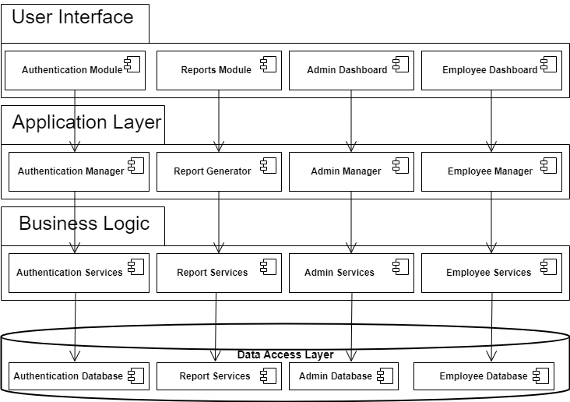

* + 1. **Use case Diagram**

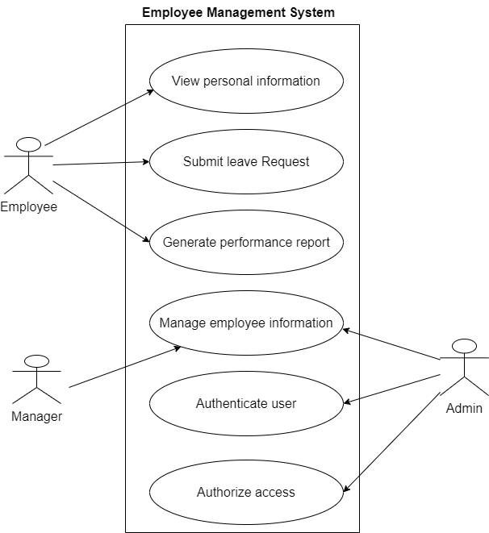

* + 1. **Activity Diagram**

**Employee Activity**

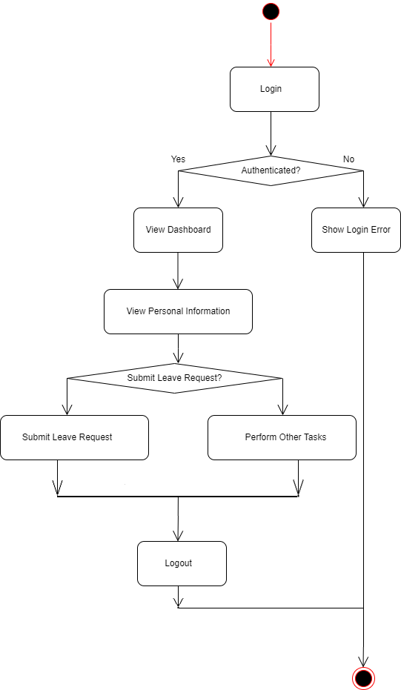

**Manager Activity**

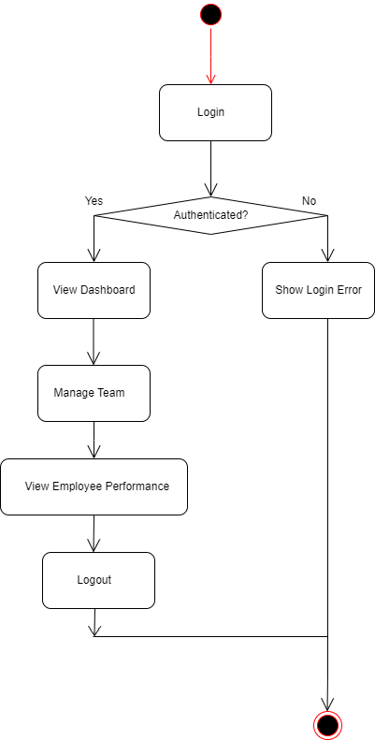

**Admin Activity**

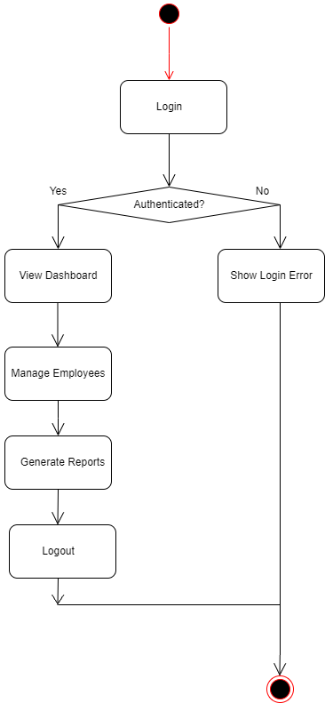

* + 1. **Class Diagram**

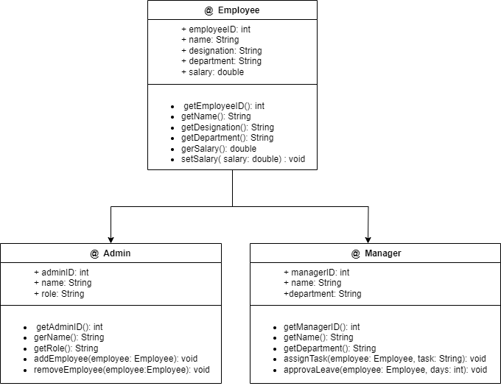

* + 1. **Sequence Diagram**

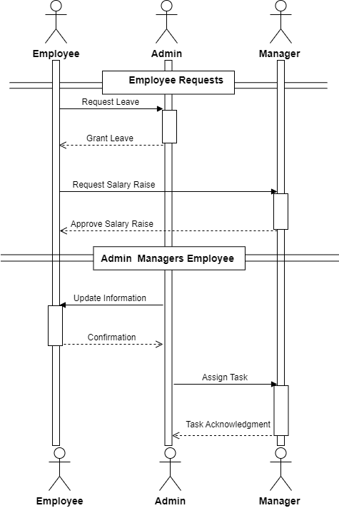

* 1. **ER Diagram**

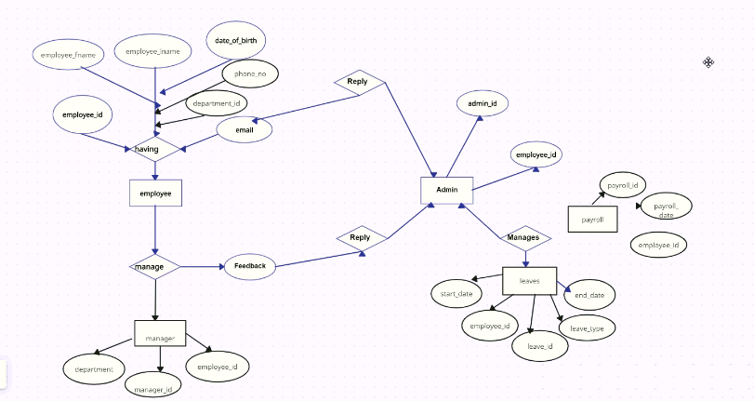

* 1. **Data Dictionary**

**Employee Table**

|  |  |  |
| --- | --- | --- |
| **Field** | **Data Type** | **Description** |
| EmployeeID | INT | Unique identifier for each employee |
| Name | VARCHAR(50) | First name of the employee |
| Email ID | VARCHAR(50) | Email Id of the employee |
| Password | VARCHAR(150) | Password of the employee login |
| Salary | INT | Salary of the employee |
| Address | VARCHAR(50) | Address of the employee |
| Image | VARCHAR(60) | Image of the employee |
| Category_id | INT | Unique identifier for each category |
| Applied_leave | INT | Applied for leave of employee |
| Leave_status | TINYINT | Check status of leave of employee |

**Manager Table**

|  |  |  |
| --- | --- | --- |
| **Field** | **Data Type** | **Description** |
| ManagerID | INT | Unique identifier for each manager |
| Name | VARCHAR(30) | Name of manger |
| Email Id | VARCHAR(50) | Email id of the manager |
| Password | VARCHAR(150) | Password of the manager login |
| Salary | INT | Salary of the manager |
| Address | VARCHAR(50) | Address of the manager |
| Image | VARCHAR(60) | Image of the manager |

**Admin Table**

|  |  |  |
| --- | --- | --- |
| **Field** | **Data Type** | **Description** |
| AdminID | INT | Unique identifier for each admin |
| Email Id | VARCHAR(50) | Email id of the admin |
| Password | VARCHAR(150) | Password of the admin login |

**Category table**

|  |  |  |
| --- | --- | --- |
| **Field** | **Data Type** | **Description** |
| Category ID | INT | Unique identifier for each Category |
| Name | VARCHAR(30) | Name of Category |

**Leave Request Table**

|  |  |  |
| --- | --- | --- |
| **Field** | **Data Type** | **Description** |
| LeaveRequestID | INT | Unique identifier for each leave request |
| Employee Name | VARCHAR(30) | Leave applied Employee name |
| Reason | VARCHAR(20) | Reason of leave (e.g., vacation, sick leave) |
| StartDate | DATE | Start date of the leave request |
| EndDate | DATE | End date of the leave request |
| Status | VARCHAR(20) | Approval status (e.g., approved, decline ) |

1. **Implementation & Testing**
   1. **Screen Snapshots**
   2. **Reports**
   3. **Testing**
      1. **Test Strategy**
      2. **Test Cases and Results**
2. **Future Enhancement**
3. **Bibliography**
   1. **Preliminary Investigation**